Lab Manual 7

# Name: Syed Muhammad Hassaan.

# Roll No: 460991

# Task 1:

1. #include <iostream>
2. using namespace std;
4. int main()
5. { //declaration of number and arrays
7. int num[10],a;
9. //using for loops to enter numbers in array
11. for(a=0;a<10;a++)
13. {
15. cout<<"please enter numbers"<<endl;
17. cin>>num[a];
19. }
21. //outputting the numbers in array
23. cout<<"numbers in the array are:"<<endl;
25. for(a=0;a<10;a++)
27. {
29. cout<<num[a]<<endl;
31. }

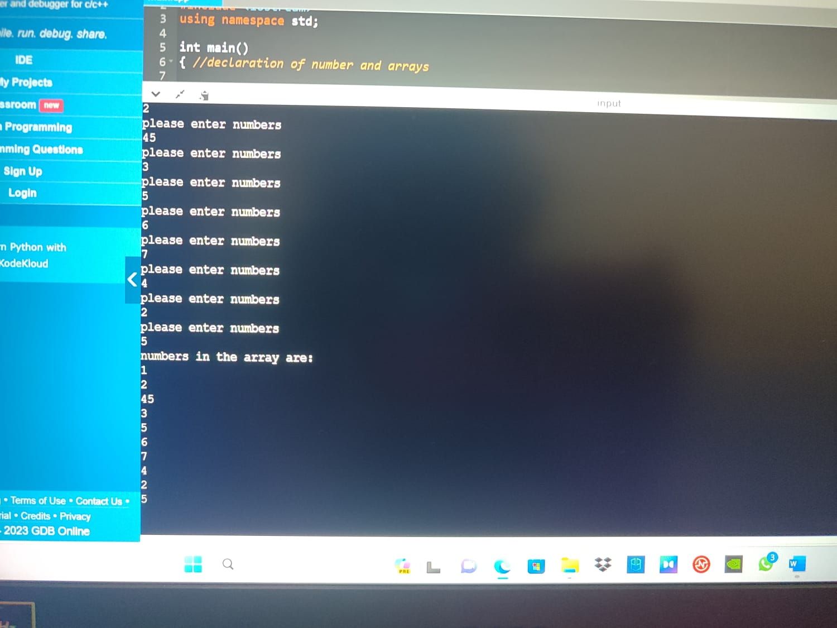

# Task 2:

1. #include <iostream>
2. using namespace std;
4. int main()
5. {
7. //declaration of array and variable
9. int num[5],sum,product,a,b;
11. sum=0;
13. product=1;
15. //using for loops to calculate sum and product of all elements for loop
17. for(a=0;a<5;a++)
19. {
21. cout<<"please enter numbers for the array"<<endl;
23. cin>>num[a] ;
25. sum=sum +num[a];
27. product=product*num[a];
29. }
31. //outputting sum and product
33. cout<<"sum and product of numbers in array is "<<sum<<" and "<<product;
35. }

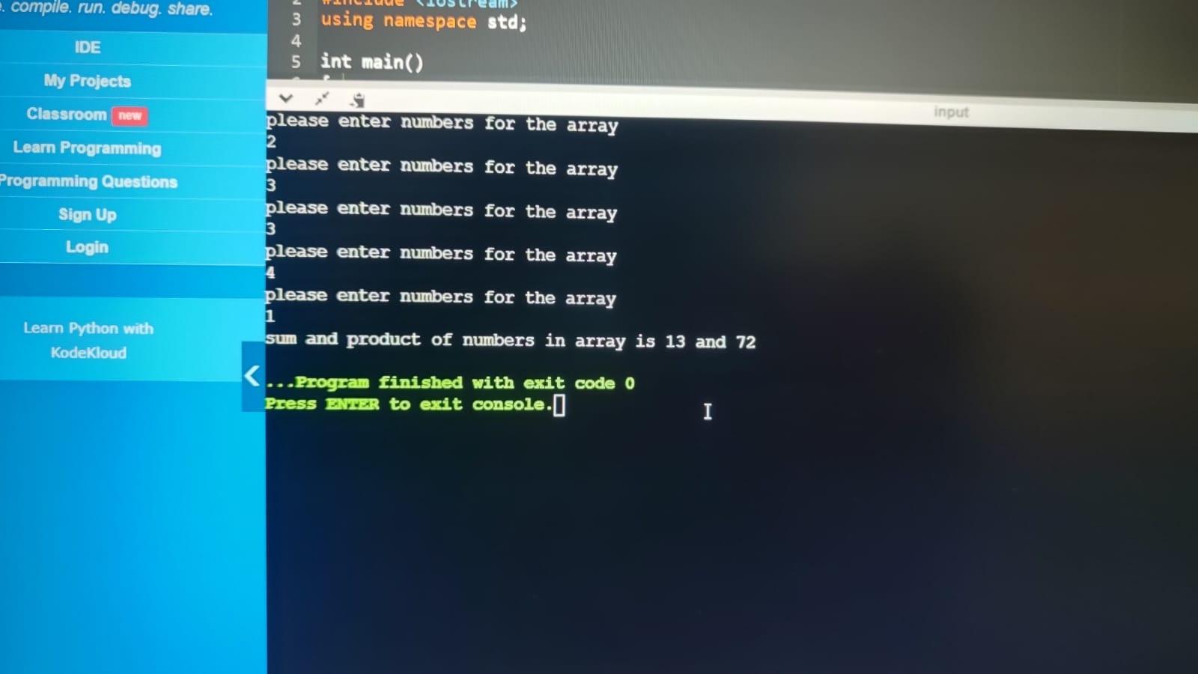

# Task 3:

1. int a=7;
3. int half=a/2;
5. char diam[a];
7. for (int b=0;b<n;b++){
9. diam[b]=' ';
11. }
13. //making first half using for loops
15. for (int b=0;b<half;b++){
17. for(int c=0;c<n;c++){
19. diam[half+b]='*';
21. diam[half-b]='*';
23. cout<<diam[c];
25. }
27. cout<<endl;
29. }
31. //making second half
33. for(int d=half-1;d>=0;d=d-1){
35. for(int e=n;e>=0;e=e-1){
37. diam[half+d]=' ';
39. diam[half-d]=' ';
41. cout<<diam[e];
43. }
45. cout<<endl;
47. }
49. }

